Lab Number: 5
Title: Implementing different page replacement algorithms
Objective: To implement and compare different page replacement algorithms, FIFO, LRU, Optimal (OPR), and Clock and analyze their performance based on the number of page faults produced for a given reference string.
Programming Language: C
IDE/Platform: DEV C++
Theory:
Page replacement is a technique used in virtual memory management. When a process requires a page that is not currently present in main memory, a page fault occurs. If all available frames are occupied, the operating system must select one existing page to remove and replace it with the required page.

The method used to select the page for removal is called a page replacement algorithm.
A page fault occurs when a requested page is not found in any of the available memory frames. The page fault ratio is calculated as:
Page Fault Ratio = 𝐍𝐮𝐦𝐛𝐞𝐫 𝐨𝐟 𝐏𝐚𝐠𝐞 𝐅𝐚𝐮𝐥𝐭𝐬
𝐓𝐨𝐭𝐚𝐥 𝐍𝐮𝐦𝐛𝐞𝐫 𝐨𝐟 𝐏𝐚𝐠𝐞 𝐑𝐞𝐟𝐞𝐫𝐞𝐧𝐜𝐞𝐬

Page fault percentage is:

Page Fault Percentage = Page Fault Ratio * 100

Page Replacement Algorithms
- FIFO (First-In First-Out)

FIFO replaces the page that has been in memory for the longest time. It maintains a pointer that moves sequentially through the frames. When a page fault occurs and all frames are full, the page at the pointer is replaced.

LRU (Least Recently Used)

LRU replaces the page that has not been used for the longest period. It assumes that a page used recently is likely to be used again soon.

OPR (Optimal Page Replacement)

Optimal Page Replacement replaces the page that will be used farthest in the future. It produces the minimum possible number of page faults for a given reference string and number of frames.
However, the algorithm requires knowledge of future page references, so it cannot be implemented exactly in a real operating system. It is mainly used as a benchmark for comparing other algorithms.

Clock Algorithm

The Clock algorithm is also called the Second-Chance algorithm. It is an improvement over FIFO that gives recently referenced pages a second chance before replacing them.

Each frame has a reference bit:

  - 1 → page has been recently used.
  - 0 → page has not been recently used.

A circular pointer moves through the frames. If the reference bit is 1, it is changed to 0 and the page is given a second chance. If the reference bit is 0, that page is replaced.

Implementation

Question 1.) Perform FIFO Page Replacement Algorithm. Algorithm:

- Start.
- Read the reference string and number of frames.
- Initialize all frames as empty.
- For each page, check whether it is present in the frames.
- If present, continue to the next page.
- If not present, replace the oldest page using FIFO order.
- Increment the page fault count.
- Repeat until all pages are processed.
- Calculate the page fault ratio.
- Display the results.
- Stop.

Source Code:
#include <stdio.h>
#define MAX 100
int isPresent(int frames[], int capacity, int page) { for (int i = 0; i < capacity; i++) {
if (frames[i] == page) return 1;
}
return 0;
}
void display(int frames[], int capacity) { for (int i = 0; i < capacity; i++) {
if (frames[i] == -1) printf("- ");
else
printf("%d ", frames[i]);
}
printf("\n");
}

int main() {
int pages[MAX], frames[MAX]; int n, capacity;
int pointer = 0, faults = 0; printf("Enter number of pages: "); scanf("%d", &n);
printf("Enter reference string:\n"); for (int i = 0; i < n; i++)
scanf("%d", &pages[i]); printf("Enter number of frames: "); scanf("%d", &capacity);
for (int i = 0; i < capacity; i++) frames[i] = -1;
printf("\n--- FIFO Page Replacement ---\n"); for (int i = 0; i < n; i++) {

if (!isPresent(frames, capacity, pages[i])) { frames[pointer] = pages[i];
pointer = (pointer + 1) % capacity; faults++;
printf("Page %d -> ", pages[i]); display(frames, capacity);
}
}
printf("\nTotal Page Faults = %d\n", faults); printf("Page Fault Ratio = %.2f\n", (float)faults / n); printf("Page Fault Percentage = %.2f%%\n",
(float)faults * 100 / n); return 0;
}

Question 2.) Perform LRU Page Replacement Algorithm. Algorithm:

- Start.
- Read the reference string and number of frames.
- Initialize all frames as empty.
- For each page, check whether it is present in the frames.
- If present, update its recent-use information.
- If not present, replace the least recently used page.
- Increment the page fault count.
- Repeat until all pages are processed.
- Calculate the page fault ratio.
- Display the results.
- Stop.

Source Code:
#include <stdio.h> #define MAX 100
void display(int frames[], int capacity)
{
for (int i = 0; i < capacity; i++)
{
if (frames[i] == -1) printf("- ");
else
printf("%d ", frames[i]);
}
printf("\n");
}
int main()
{
int pages[MAX], frames[MAX], recent[MAX]; int n, capacity;
int faults = 0;
printf("Enter number of pages: "); scanf("%d", &n);
printf("Enter reference string:\n"); for (int i = 0; i < n; i++)
scanf("%d", &pages[i]); printf("Enter number of frames: "); scanf("%d", &capacity);
for (int i = 0; i < capacity; i++)
{
frames[i] = -1;
recent[i] = -1;

}
printf("\n--- LRU Page Replacement ---\n"); for (int i = 0; i < n; i++)
{
int page = pages[i]; int found = -1;
// Check if page is already present for (int j = 0; j < capacity; j++)
{
if (frames[j] == page)
{
found = j; break;
}
}
// Page hit
if (found != -1)
{
recent[found] = i;
}
// Page fault else
{
int replace = -1;
// Find empty frame
for (int j = 0; j < capacity; j++)
{
if (frames[j] == -1)
{
replace = j; break;
}
}
// Find least recently used frame if (replace == -1)
{
replace = 0;
for (int j = 1; j < capacity; j++)
{
if (recent[j] < recent[replace]) replace = j;
}
}
frames[replace] = page; recent[replace] = i; faults++;

printf("Page %d -> ", page); display(frames, capacity);
}
}
printf("\nTotal Page Faults = %d\n", faults); printf("Page Fault Ratio = %.2f\n", (float)faults / n); printf("Page Fault Percentage = %.2f%%\n",
(float)faults * 100 / n); return 0;
}

Question 3.) Perform Optimal Page Replacement Algorithm. Algorithm:

- Start.
- Read the reference string and number of frames.
- Initialize all frames as empty.
- For each page, check whether it is present in the frames.
- If present, continue to the next page.
- If not present, replace the page that will be used farthest in the future.
- Increment the page fault count.
- Repeat until all pages are processed.
- Calculate the page fault ratio.
- Display the results.
- Stop.

Source Code:
#include <stdio.h> #define MAX 100
int isPresent(int frames[], int capacity, int page)
{
for (int i = 0; i < capacity; i++)
{
if (frames[i] == page) return 1;
}
return 0;
}
void display(int frames[], int capacity)
{
for (int i = 0; i < capacity; i++)
{

if (frames[i] == -1) printf("- ");
else
printf("%d ", frames[i]);

}
printf("\n");
}
int findOptimal(int pages[], int n, int frames[], int capacity, int current)
{
int farthest = -1; int index = -1;
for (int i = 0; i < capacity; i++)
{
int j;
// Find next use of current frame for (j = current + 1; j < n; j++)
{
if (frames[i] == pages[j]) break;
}
// Page is never used again if (j == n)
return i;
// Find page used farthest in future if (j > farthest)
{
farthest = j; index = i;
}
}
return index;
}
int main()
{

int pages[MAX], frames[MAX]; int n, capacity;
int faults = 0;
printf("Enter number of pages: "); scanf("%d", &n);
printf("Enter reference string:\n"); for (int i = 0; i < n; i++)
scanf("%d", &pages[i]); printf("Enter number of frames: "); scanf("%d", &capacity);
for (int i = 0; i < capacity; i++) frames[i] = -1;
printf("\n--- Optimal Page Replacement ---\n"); for (int i = 0; i < n; i++)
{
if (!isPresent(frames, capacity, pages[i]))
{
int empty = -1;
// Find empty frame
for (int j = 0; j < capacity; j++)
{
if (frames[j] == -1)
{
empty = j; break;
}
}
if (empty != -1)
{
frames[empty] = pages[i];
}

else
{
int replace = findOptimal( pages, n, frames, capacity, i);
frames[replace] = pages[i];
}
faults++;
printf("Page %d -> ", pages[i]); display(frames, capacity);
}
}
printf("\nTotal Page Faults = %d\n", faults); printf("Page Fault Ratio = %.2f\n", (float)faults / n); printf("Page Fault Percentage = %.2f%%\n",
(float)faults * 100 / n); return 0;
}

Question 4.) Perform Clock Page Replacement Algorithm. Algorithm:

- Start.
- Read the reference string and number of frames.
- Initialize all frames and reference bits.
- For each page, check whether it is present in the frames.
- If present, set its reference bit to 1.
- If not present, find a frame with reference bit 0 using the clock pointer.
- Replace the selected page and set its reference bit to 1.
- Increment the page fault count.
- Repeat until all pages are processed.
- Calculate the page fault ratio.
- Display the results.
- Stop.

Source Code:
#include <stdio.h> #define MAX 100

void display(int frames[], int capacity)
{
for (int i = 0; i < capacity; i++)
{
if (frames[i] == -1) printf("- ");
else
printf("%d ", frames[i]);
}
printf("\n");
}
int main()
{
int pages[MAX], frames[MAX], reference[MAX]; int n, capacity;
int pointer = 0; int faults = 0;

printf("Enter number of pages: "); scanf("%d", &n);
printf("Enter reference string:\n"); for (int i = 0; i < n; i++)
scanf("%d", &pages[i]); printf("Enter number of frames: "); scanf("%d", &capacity);
// Initialize frames and reference bits for (int i = 0; i < capacity; i++)
{
frames[i] = -1;
reference[i] = 0;
}
printf("\n--- Clock Page Replacement ---\n"); for (int i = 0; i < n; i++)
{
int page = pages[i]; int found = -1;
// Check whether page is present

for (int j = 0; j < capacity; j++)
{

if (frames[j] == page)
{
found = j; break;
}
}
// Page hit
if (found != -1)
{
reference[found] = 1;
}
// Page fault else
{
// Find frame with reference bit 0 while (reference[pointer] == 1)
{
reference[pointer] = 0;
pointer = (pointer + 1) % capacity;
}
frames[pointer] = page; reference[pointer] = 1;
pointer = (pointer + 1) % capacity; faults++;
printf("Page %d -> ", page); display(frames, capacity);
}
}
printf("\nTotal Page Faults = %d\n", faults); printf("Page Fault Ratio = %.2f\n", (float)faults / n); printf("Page Fault Percentage = %.2f%%\n",
(float)faults * 100 / n); return 0;
}

Outputs:

Q.1 Output:
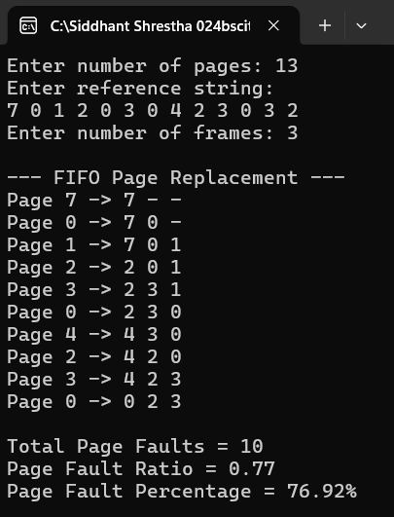

Q.2 Output:
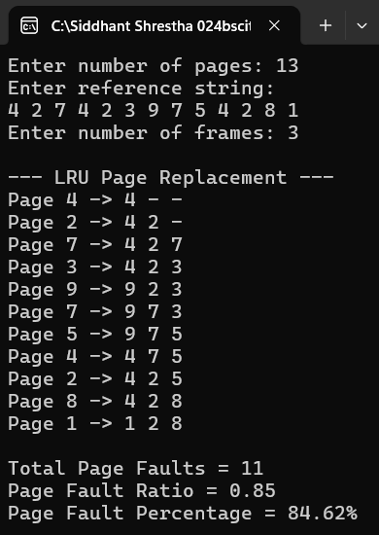

Q.3 Output:
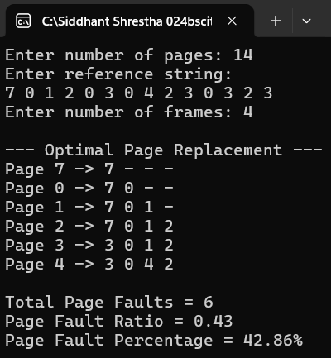

Q.4 Output:
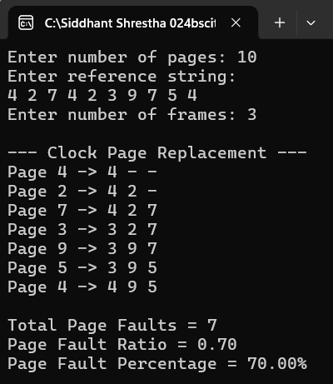

Discussion:
FIFO replaces the page that has been in memory longest, regardless of usage, simply with a queue, but can suffer from Belady's Anomaly. LRU replaces the page unused for the longest time, tracking working sets more accurately via temporal locality, at the cost of extra bookkeeping. OPR replaces the page needed furthest in the future, giving the theoretical best performance, but requires future knowledge, making it usable only as a benchmark. Clock approximates LRU using use bits and a circular pointer, giving pages with a use bit of 1 a second chance offering LRU-like performance with much lower overhead, making it practical for real systems.
Conclusion:
FIFO is simple to implement but can perform poorly and even suffer from Belady's Anomaly. LRU generally performs better by using recent history as a predictor of future behavior but requires extra bookkeeping. Optimal replacement gives the theoretical minimum number of page faults and is used only as a benchmark, since it requires future knowledge unavailable in practice. Clock offers a practical, low-overhead approximation of LRU using reference bits, making it a common choice in real operating systems. Overall, the choice of page replacement algorithm involves a trade-off between implementation simplicity, overhead, and how closely it approximates optimal performance.

